Spring Newsletter – The last blast of winter!
P.O. Box 952 Invercargill 9810
southlandskiclub@gmail.com
www.southlandskiclub.org.nz

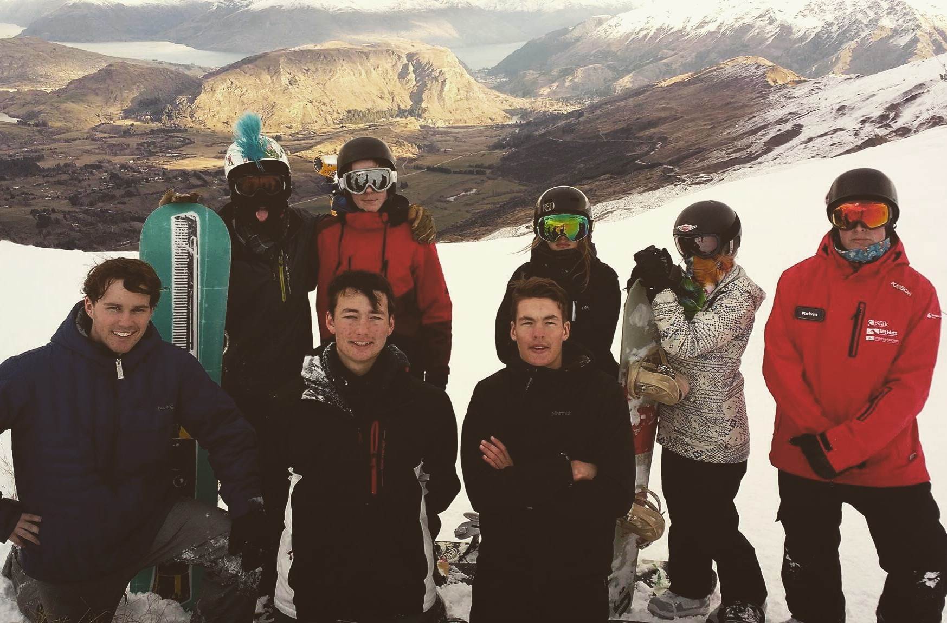

Next Ski Club meeting
Tues 11-Oct 7:00pm
Winton Middle Pub
emilyjgreen95@gmail.com for an agenda & to register your attendance. All welcome!

LODGE GROUP BOOKINGS
August
1-2nd & 4th S’land Boys High Sch.
8-9th Aparima College
11-12th Remuera School
15-18th Roncalli College
20th Arrowtown Scouts
21-22nd Fairfield School
24-25th Blue Mountain College
26-27th Inv’l City Baptist Church Youth Group
September
1-3rd Diabetes Group
8th Waiau College
10th Verdon College
16-17th Queenstown Scouts

2017 Bookings July-August
26-27th Glenorchy School
28-29th Tahuna Intermediate
31st-3rd Liberton Christian Sch.
24-25th Remuera School
29-31st Warrington School

Dear members
With the bulk of school sports out of the way for now, why not take the opportunity to stay at our lodge & make the most of the convenience of being right there on the mountain. “I just love watching the lights of the cars heading back beside Lake Wakatipu at the end of the day, while we relax beside the fire with a mulled wine”.
Our lodge is becoming increasingly popular with families from throughout NZ & Australia as word gets out; but the lodge is there for Southlanders first & foremost. Please do use it or I’m afraid that we may lose the warm club atmosphere that we’re known for.
Sarah Kennedy, president

Lodge bookings

Self-catering. Fully equipped modern kitchen, 4 bunkrooms, drying room & 2 separate bathrooms. Welcoming custodians in residence. Popular for wider family gatherings & groups of friends.
Our current group bookings are on the RHS panel. Often a spare bunkroom is available during group booking periods. Go to www.southlandskiclub.org.nz to view our lodge availability calendar & contact our Custodians Alan & Jan on 027 442 5198 or email southlandskiclub@gmail.com
Bookings may also be made for accommodation during the off-season under certain circumstances.
Ski week review
Please support Sliver Fern Farms

Generous providers of lamb
& warm beanies
for our 2016 ski weeks.

Ski club office bearers

President & funding
Sarah Kennedy 021-143-4987

Vice President
Martha Hogan

Treasurer
Vicky Murphy 027-275-0665

Secretary
Emily Green

Lodge bookings & publicity
Janine Rauber 027-254-6050

Lodge maintenance manager
Wayne Hopcroft

Lodge custodians
Alan & Jan Burrows

Lodge cellphone
Ski season only 027-442-5198

Our ski weeks were a huge success once again and are reviewed below by our Host Parents. Next year we hope to have contributions from some of our participants themselves.
We were lucky to be supported by Silver Fern Farms with legs of lamb for our traditional Thursday night dinner, during which we host the children’s instructors. They also supplied boxes of warm beanies which were well received too. Fonterra generously came to the party with 2 large blocks of cheese. Many families also supplied delicious lasagnas, baking, soup & produce; for which we are very grateful for too. These contributions not only help to keep the costs to an affordable level for families, but provide a homely feel.
The club also acknowledges the wonderful commitment that the parent helpers make every year to give up their time to help us run the ski weeks. Thank you Sandra Flahive, Tim Smalley, Debby Egan & Duane Ashman for assisting with week 1 & to Frank van Miltenburg, Deb Warrender, Quentin Mitchell & Debbie Drummond during week 2. Our ski weeks would not be possible without them.
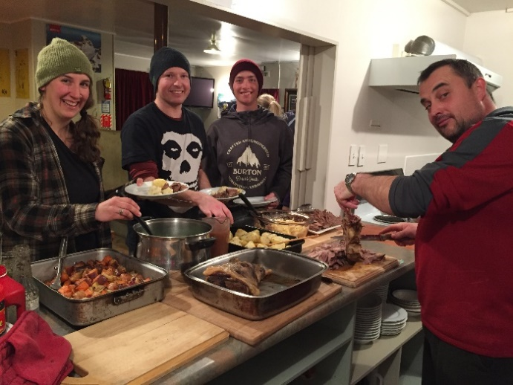
Tim Smalley expertly caving a Silver Fern Farms roast leg of lamb for our appreciative instructors.

Ski Week 1
Sarah & John Kennedy
(Ski week host parents)

The snowmakers worked overtime to ensure a great start to our first ski week. A storm closed the field on Wednesday & after a lazy morning we took off into Queenstown where energy was burned off with activities such as ice-skating & trampolining; returning to the lodge in time for a wonderful meal conjured up by the menfolk & a fireside movie night.
The fresh snow was fantastic, but came in tandem with the crowds, especially with The Remarkables closing on Friday; a great time to be in lessons & short-cut the queues! Friday night was a highlight with night skiing & Mortimer’s 12th birthday celebrations. It was great getting to know the children & parent helpers. I’m sure that everyone improved on their skiing or snowboarding & we are looking forward to having you all back next year.
Ski Week 2 Martha Hogan and Wayne Hopcroft (Ski week host parents).
Sunday 17th August saw 26 kids eagerly flocking into the Southland Ski Hut loaded up with sleeping bags and ski gear overflowing from bags bursting at the seams. All grinning from ear to ear in anticipation of what is always a great week. The laughter and banter that oozes from their bunk rooms is contagious as they are reunited with old friends. It’s not long before new kids are encompassed into their circle of jocularity and parents are ousted…their job done…at least for now!!! We, as a group, couldn’t have timed things better. The temperature on the mountain had dropped substantially over the previous week and Coronet Peak had been hard-out snow making. This, along with the new snow that fell, meant skiing conditions for us was primo and remained like that for the entire week. Perfect!!
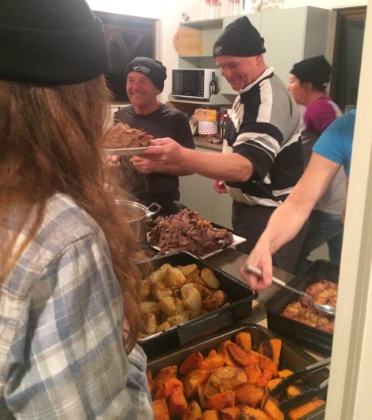
Our Thursday Silver Farms Roast night was well patronised by our instructors who all enjoyed chatting with the children and participating in the traditional quiz. The children were all extremely well-mannered and great hosts. The nightly entertainment and the light hearted teasing of each other had us all at times in stitches.
Thank you for sending us a great bunch of children. We definitely look forward to seeing them all again next year.
Veteran members

We are anxious to learn about our early years of our club history since it was formed in 1933. If you are a veteran club member or know of someone who is we’d love to hear from you.

We are particularly keen to invite a veteran member as guest speaker at our next AGM in March-April; but it would also be wonderful to put together a commemorative book full of stories, photographs & documents from our early years.
Please contact us at southlandskiclub@gmail.com
Community Trust of Southland & the Southland District Council

We have been very fortunate to receive $1,600 and $750 respectively from CTOS & SDC towards the replacement of our two massive hot water cylinders. This work was completed before winter & the new cylinders should last another 30yrs or more.
We have also replaced couches & our freezer & installed a second oven/stove & dishwasher. The lodge is continuously being upgraded & is a well maintained & modern lodge; a very comfortable place to stay. We are most appreciative to Alan & Jan Burrows for their maintenance & cleaning over the years & also to Wayne & Heather Hopcroft for their tremendous contribution during the latest upgrades, well over & above the call of duty.

Club Membership Currently we have 41 individual members & 25 couples/families – over 150 individuals!!
“A reduction in membership rates & some good publicity pre-season has resulted in the biggest membership I have ever seen with the club in the 7 yrs that I've been involved” – Vicki Murphy (treasurer).

